Aequs EduTrack — Project Timeline & Visual Overview
Executive Engineering Roadmap, Visual Gantt Charts & Architecture Milestones

Executive Snapshot
Project Name | Aequs EduTrack (Educational CSR Management Platform)
Active Timeframe | August 12, 2026 – September 07, 2026
Project Duration | 27 Calendar Days (14 Active Development Days)
Total Git Commits | 61 Commits (+ 1 Architectural Optimization Sprint)
Core Engineering Team | 2 Primary Contributors (Rishab / Code-Cool-2006, Saloni Dalvi)
Rishab / Code-Cool-2006 | 42 Commits (69%) — Lead Architecture, UI/UX, School/Volunteer Portals, Testing, DevOps
Saloni Dalvi / salonidalvi-008 | 19 Commits (31%) — Core Scaffolding, Distributions, CourseMaster, Internship Portal, Eligibility
Automated Test Suite | 78 / 78 Automated Tests Passing (100% OK in 5.6s)

Visual Roadmap & Gantt Chart
The visual Gantt chart illustrates the end-to-end multi-week timeline across all 10 engineering phases from initial project scaffolding to architectural audit:
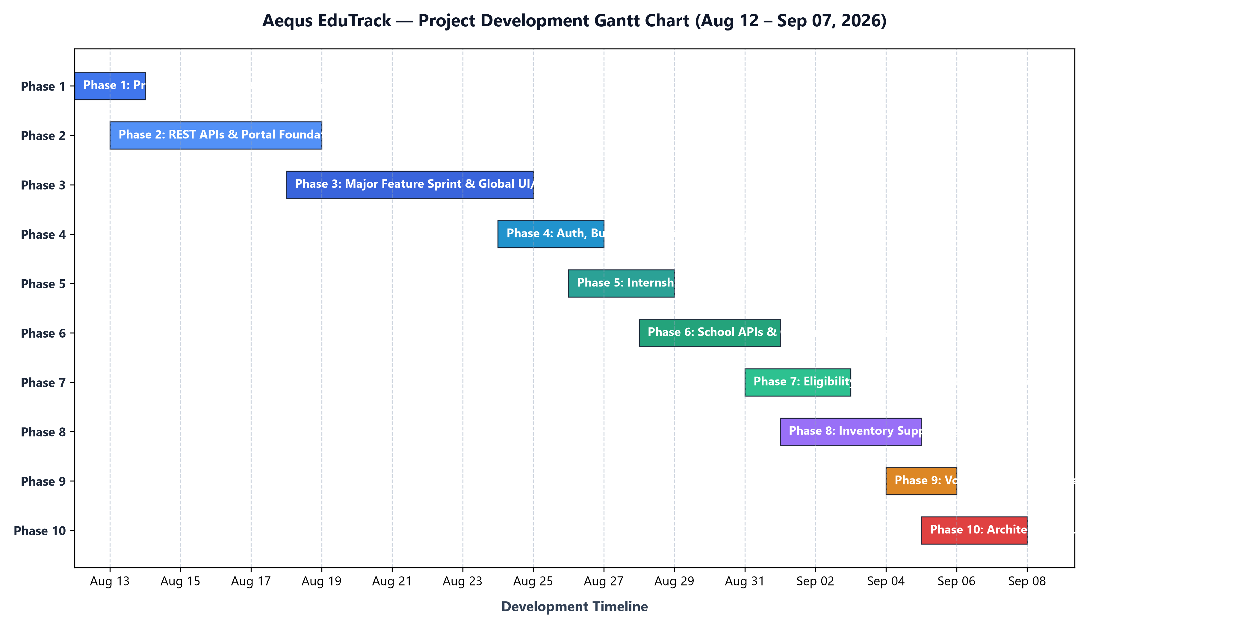

Module Evolution & Feature Maturation
The lifecycle diagram below traces the release and maturation milestones across the core functional modules of Aequs EduTrack:
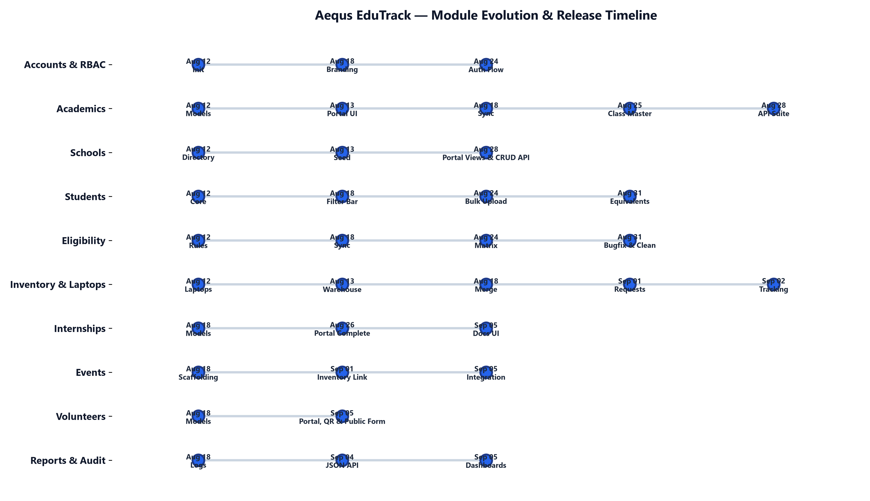

Development Phases & Commit Distribution
Distribution of development activity across phases alongside total team commit share:
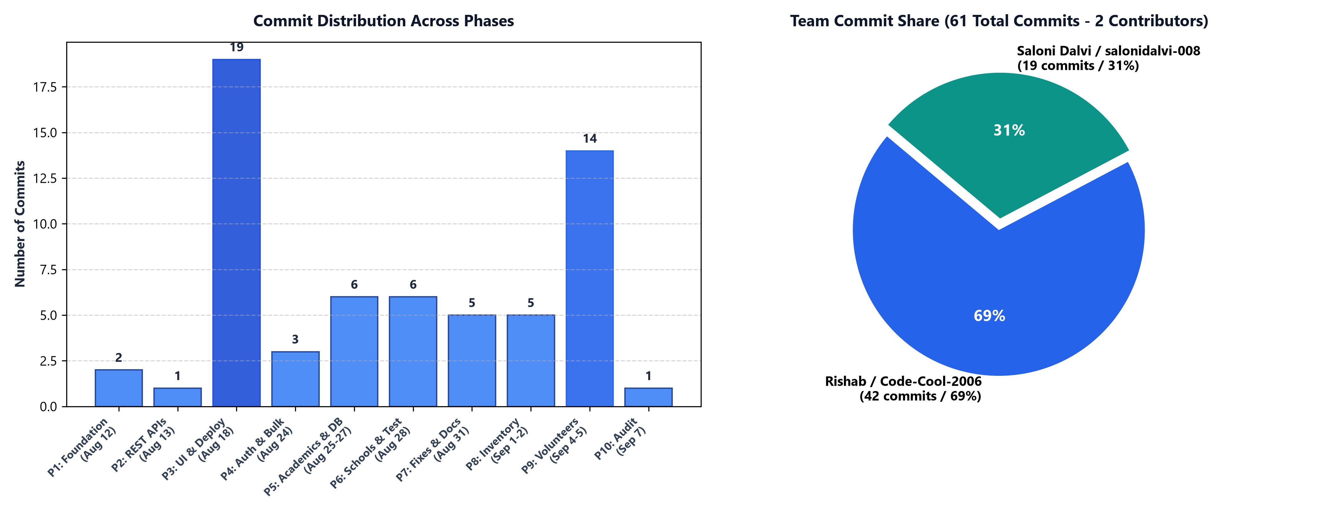

Phase-by-Phase Chronological Log
Detailed breakdown of engineering deliverables, architectural milestones, and commit activity across all 10 phases:

Phase 1: Project Scaffolding & Core Architecture
Dates: August 12, 2026 | Volume: 2 commits | Lead: Saloni Dalvi
- Initialized Django project with custom User model and 5 RBAC roles (Super Admin, Admin, Accountant, Volunteer, Event Coordinator).
- Core database models established: School (UDISE codes, headmasters), Student (demographics), AcademicRecord (marks, promotion), EligibilityRecord (5 benefit types), and Laptop / LaptopAssignment tracking.
- Basic list and creation forms for students, schools, and benefit distributions.

Phase 2: REST APIs & Management Services
Dates: August 13, 2026 | Volume: 1 commit | Lead: Rishab
- Warehouse models: InventoryItem and StockTransaction for stock-in/stock-out management.
- Interactive Academics Portal and Inventory Portal templates.
- Automated CLI seed commands: seed_schools, seed_inventory, seed_academics.
- Multi-item StudyKit services layer.

Phase 3: Major Feature Sprint, UI/UX Overhaul & Production Deployment
Dates: August 18, 2026 | Volume: 19 commits | Lead: Rishab, Saloni Dalvi
- Added Internship module (programs, candidate placements, milestones).
- Foundational scaffolding for Events, Volunteers, and Reports.
- Sidebar Evolution: 3 iterations (dark -> unified dark -> high-contrast royal blue/white light theme).
- Global Design System: Unified typography, custom CSS tokens, compact data density, and shadcn-style card aesthetics.
- Real-world Belagavi district mock data seeder.
- Production Cloud Deployment: Docker containerization, Render PaaS blueprint, Gunicorn WSGI, Whitenoise static streaming, and PostgreSQL database support.

Phase 4: Authentication & Bulk Data Operations
Dates: August 24, 2026 | Volume: 3 commits | Lead: Rishab, Saloni Dalvi
- Branded login/logout portal featuring Aequs SEZ background and glassmorphism styling.
- Session protection and role authentication guards across all portal views.
- CSV Bulk Upload engine supporting Students, Schools, Academics, and Inventory.

Phase 5: Academic Enhancements & Enterprise SQL Server
Dates: August 25–27, 2026 | Volume: 6 commits | Lead: Saloni Dalvi, Rishab
- CourseMaster model for dynamic curriculum streams and grades.
- Configured Microsoft SQL Server (mssql-django / pyodbc) for on-prem enterprise deployments.
- Completed full Internship Management Portal with milestone tracking and stipend evaluation.

Phase 6: School Management Portal & Automated Test Suite
Dates: August 28, 2026 | Volume: 6 commits | Lead: Rishab, Saloni Dalvi
- Dedicated School Portal dashboard with grade-by-grade student strength matrix (Classes 1–10).
- Engineered comprehensive 78-case automated test suite validating models, permissions, and REST endpoints.

Phase 7: Eligibility Engine Fixes & Class Resolvers
Dates: August 31, 2026 | Volume: 5 commits | Lead: Saloni Dalvi, Rishab
- Fixed critical eligibility bug where higher-education degrees (BE, Diploma, ITI, PUC) were conflated with K-10 school grades.
- Added resilient class name resolver (10th <-> Class 10, PUC <-> 12th).
- Published initial User Manual and Timeline documentation.

Phase 8: Inventory Logistics, Resource Requests & PR #1
Dates: September 01–02, 2026 | Volume: 5 commits | Lead: Rishab, Saloni Dalvi
- Event Resource Requests: Event coordinators can request warehouse equipment directly.
- Repaired inventory bulk upload with atomic transaction handling.
- Stock status indicators (In Stock, Low Stock, Depleted) in inventory views.
- Merged Pull Request #1 into main codebase.

Phase 9: Volunteer Management System, QR Generation & Public Registration
Dates: September 04–05, 2026 | Volume: 14 commits | Lead: Rishab, Saloni Dalvi
- Complete Volunteer Portal: Volunteer directory, hours contributed, event assignments, and activity logs.
- Tokenized VolunteerFormLink generator allowing administrators to share secure external signup links.
- Live dynamic PNG QR code generation (Reed-Solomon Level H error correction).
- Public, standalone mobile-responsive volunteer registration page with activity audit logging.
- Direct CSV and Excel export endpoints for volunteer rosters.

Phase 10: Architectural Audit & Codebase Streamlining
Dates: September 07, 2026 | Volume: 1 sprint | Lead: Rishab
- Purged 17 dead backup and text dump files (project_frontend.txt, *_backup.py, *.corrupt-backup).
- Removed 5 empty skeleton apps (audit, documents, notifications, donations, expense_management) from disk and INSTALLED_APPS.
- Unified duplicate QR generation views into a single reusable handler.
- Removed redundant transitive dependencies (asgiref, sqlparse) from requirements.txt.
- Net Impact: -29,811 lines of dead code removed, 78/78 tests passing (100% green), 0 system check issues.

Contributor Breakdown (61 Total Commits)
The repository history reflects contributions from two primary software engineers:
Contributor | Commits | Share | Functional Domain & Impact
Rishab / Code-Cool-2006 | 42 | 69% | Lead Architect, UI/UX & Systems Engineer  • REST APIs & management commands (seed_schools, seed_inventory, seed_academics)  • UI/UX design system (3 sidebar iterations, global CSS, shadcn card aesthetics)  • School Management Portal, Academics Portal, and Inventory Portal  • Automated 78-case unit/API test suite (100% pass rate in 5.6s)  • Volunteer Management System (CRUD, public signup forms, live QR generation)  • Production deployment blueprints (Docker, Render PaaS, Gunicorn, Whitenoise)  • Codebase optimization (-29,811 dead lines purged across 52 files)
Saloni Dalvi / salonidalvi-008 | 19 | 31% | Core Services & Logistics Engineer  • Initial project foundation and core schema scaffolding (13 apps)  • Benefit distribution services and Study Kit assembly workflows  • Dynamic CourseMaster and academic grade/stream filters  • Enterprise Microsoft SQL Server (mssql-django / pyodbc) integration  • Full Internship Management Portal (company tracks, milestones, stipends)  • Eligibility bugfix (course separation & class equivalent resolution)  • Bulk CSV onboarding pipelines across models
Aequs EduTrack Project Timeline & Visual Overview • September 07, 2026
© 2026 Aequs Foundation. All rights reserved.

